**Inheritance in Python**

The **process of inheriting the properties of the parent class into a child class is called inheritance**. The existing class is called a base class or parent class and the new class is called a subclass or child class or derived class.

In this Python lesson, you will learn inheritance, method overloading, method overriding, types of inheritance, and MRO (Method Resolution Order).

In [Object-oriented programming](https://pynative.com/python/object-oriented-programming/), inheritance is an important aspect. The main purpose of inheritance is the **reusability** of code because we can use the existing [class](https://pynative.com/python-classes-and-objects/) to create a new class instead of creating it from scratch.

In inheritance, the child class acquires all the data members, properties, and functions from the parent class. Also, a child class can also provide its specific implementation to the methods of the parent class.

**For example**, In the real world, Car is a sub-class of a Vehicle class. We can create a Car by inheriting the properties of a Vehicle such as Wheels, Colors, Fuel tank, engine, and add extra properties in Car as required.

**Syntax**

**class** BaseClass:

Body of base **class**

class DerivedClass(BaseClass):

Body of derived **class**

**Also, See**

* [Python OOP Exercise](https://pynative.com/python-object-oriented-programming-oop-exercise/)

**Table of contents**

* [Types Of Inheritance](https://pynative.com/python-inheritance/#h-types-of-inheritance)
* [Single Inheritance](https://pynative.com/python-inheritance/#h-single-inheritance)
* [Multiple Inheritance](https://pynative.com/python-inheritance/#h-multiple-inheritance)
* [Multilevel inheritance](https://pynative.com/python-inheritance/#h-multilevel-inheritance)
* [Hierarchical Inheritance](https://pynative.com/python-inheritance/#h-hierarchical-inheritance)
* [Hybrid Inheritance](https://pynative.com/python-inheritance/#h-hybrid-inheritance)
* [Python super() function](https://pynative.com/python-inheritance/#h-python-super-function)
* [issubclass()](https://pynative.com/python-inheritance/#h-issubclass)
* [Method Overriding](https://pynative.com/python-inheritance/#h-method-overriding)
* [Method Resolution Order in Python](https://pynative.com/python-inheritance/#h-method-resolution-order-in-python)
* [Next Steps](https://pynative.com/python-inheritance/#h-next-steps)

**Types Of Inheritance**

In Python, based upon the number of child and parent classes involved, there are five types of inheritance. The type of inheritance are listed below:

1. Single inheritance
2. Multiple Inheritance
3. Multilevel inheritance
4. Hierarchical Inheritance
5. Hybrid Inheritance

Now let’s see each in detail with an example.

**Single Inheritance**

In single inheritance, a child class inherits from a single-parent class. Here is one child class and one parent class.

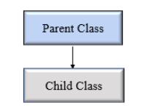Python Single Inheritance

**Example**

Let’s create one parent class called ClassOne and one child class called ClassTwo to implement single inheritance.

# Base class

**class** Vehicle:

**def** Vehicle_info(self):

**print**('Inside Vehicle class')

# Child class

**class** Car(Vehicle):

**def** car_info(self):

**print**('Inside Car class')

# Create object of Car

car = Car()

# access Vehicle's info using car object

car.Vehicle_info()

car.car_info()

**Output**

Inside Vehicle class

Inside Car class

**Multiple Inheritance**

In multiple inheritance, one child class can inherit from multiple parent classes. So here is one child class and multiple parent classes.

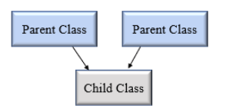Python Multiple Inheritance

**Example**

# Parent class 1

**class** Person:

**def** person_info(self, name, age):

**print**('Inside Person class')

**print**('Name:', name, 'Age:', age)

# Parent class 2

**class** Company:

**def** company_info(self, company_name, location):

**print**('Inside Company class')

**print**('Name:', company_name, 'location:', location)

# Child class

**class** Employee(Person, Company):

**def** Employee_info(self, salary, skill):

**print**('Inside Employee class')

**print**('Salary:', salary, 'Skill:', skill)

# Create object of Employee

emp = Employee()

# access data

emp.person_info('Jessa', 28)

emp.company_info('Google', 'Atlanta')

emp.Employee_info(12000, 'Machine Learning')

**Output**

Inside Person class

Name: Jessa Age: 28

Inside Company class

Name: Google location: Atlanta

Inside Employee class

Salary: 12000 Skill: Machine Learning

In the above example, we created two parent classes Person and Company respectively. Then we create one child called Employee which inherit from Person and Company classes.

**Multilevel inheritance**

In multilevel inheritance, a class inherits from a child class or derived class. Suppose three classes A, B, C. A is the superclass, B is the child class of A, C is the child class of B. In other words, we can say a **chain of classes** is **called multilevel inheritance.**

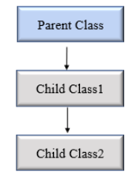Python Multilevel Inheritance

**Example**

# Base class

**class** Vehicle:

**def** Vehicle_info(self):

**print**('Inside Vehicle class')

# Child class

**class** Car(Vehicle):

**def** car_info(self):

**print**('Inside Car class')

# Child class

**class** SportsCar(Car):

**def** sports_car_info(self):

**print**('Inside SportsCar class')

# Create object of SportsCar

s_car = SportsCar()

# access Vehicle's and Car info using SportsCar object

s_car.Vehicle_info()

s_car.car_info()

s_car.sports_car_info()

**Output**

Inside Vehicle class

Inside Car class

Inside SportsCar class

In the above example, we can see there are three classes named Vehicle, Car, SportsCar. Vehicle is the superclass, Car is a child of Vehicle, SportsCar is a child of Car. So we can see the **chaining of classes**.

**Hierarchical Inheritance**

In Hierarchical inheritance, more than one child class is derived from a single parent class. In other words, we can say one parent class and multiple child classes.

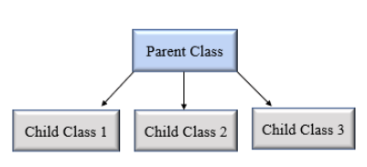Python hierarchical inheritance

**Example**

Let’s create ‘Vehicle’ as a parent class and two child class ‘Car’ and ‘Truck’ as a parent class.

**class** Vehicle:

**def** info(self):

**print**("This is Vehicle")

**class** Car(Vehicle):

**def** car_info(self, name):

**print**("Car name is:", name)

**class** Truck(Vehicle):

**def** truck_info(self, name):

**print**("Truck name is:", name)

obj1 = Car()

obj1.info()

obj1.car_info('BMW')

obj2 = Truck()

obj2.info()

obj2.truck_info('Ford')

**Output**

This is Vehicle

Car name is: BMW

This is Vehicle

Truck name is: Ford

**Hybrid Inheritance**

When inheritance is consists of multiple types or a combination of different inheritance is called hybrid inheritance.

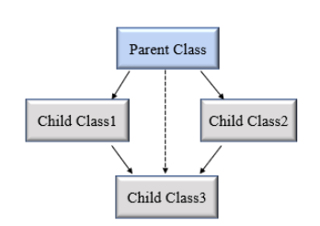Python hybrid inheritance

**Example**

**class** Vehicle:

**def** vehicle_info(self):

**print**("Inside Vehicle class")

**class** Car(Vehicle):

**def** car_info(self):

**print**("Inside Car class")

**class** Truck(Vehicle):

**def** truck_info(self):

**print**("Inside Truck class")

# Sports Car can inherits properties of Vehicle and Car

**class** SportsCar(Car, Vehicle):

**def** sports_car_info(self):

**print**("Inside SportsCar class")

# create object

s_car = SportsCar()

s_car.vehicle_info()

s_car.car_info()

s_car.sports_car_info()

**Note**: In the above example,**hierarchical**and**multiple** inheritance exists. Here we created, parent class Vehicle and two child classes named Car and Truck this is hierarchical inheritance.

Another is SportsCar inherit from two parent classes named Car and Vehicle. This is multiple inheritance.

**Python super() function**

When a class inherits all properties and behavior from the parent class is called inheritance. In such a case, the inherited class is a subclass and the latter class is the parent class.

In child class, we can refer to parent class by using the super() function. The super function returns a temporary object of the parent class that allows us to call a parent class method inside a child class method.

**Benefits of using the super() function.**

1. We are not required to remember or specify the parent class name to access its methods.
2. We can use the super() function in both **single** and **multiple inheritances**.
3. The super() function support code **reusability** as there is no need to write the entire function

**Example**

**class** Company:

**def** company_name(self):

**return** 'Google'

**class** Employee(Company):

**def** info(self):

# Calling the superclass method using super()function

c_name = **super**().company_name()

**print**("Jessa works at", c_name)

# Creating object of child class

emp = Employee()

emp.info()

**Output**:

Jessa works at Google

In the above example, we create a parent class Company and child class Employee. In Employee class, we call the parent class method by using a super() function.

**issubclass()**

In Python, we can verify whether a particular class is a subclass of another class. For this purpose, we can use Python built-in function issubclass(). This function returns True if the given class is the subclass of the specified class. Otherwise, it returns False.

**Syntax**

**issubclass**(**class**, classinfo)

Where,

* class: class to be checked.
* classinfo: a class, type, or a tuple of classes or data types.

**Example**

**class** Company:

**def** fun1(self):

**print**("Inside parent class")

**class** Employee(Company):

**def** fun2(self):

**print**("Inside child class.")

**class** Player:

**def** fun3(self):

**print**("Inside Player class.")

# Result True

**print**(**issubclass**(Employee, Company))

# Result False

**print**(**issubclass**(Employee, **list**))

# Result False

**print**(**issubclass**(Player, Company))

# Result True

**print**(**issubclass**(Employee, (**list**, Company)))

# Result True

**print**(**issubclass**(Company, (**list**, Company)))

Also, see [Python isinstance()](https://pynative.com/python-isinstance-explained-with-examples/).

**Method Overriding**

In inheritance, all members available in the parent class are by default available in the child class. If the child class does not satisfy with parent class implementation, then the child class is allowed to redefine that method by extending additional functions in the child class. This concept is called **method overriding**.

When a child class method has the same name, same parameters, and same return type as a method in its superclass, then the method in the child is said to **override** the method in the parent class.

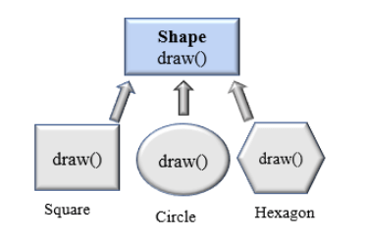Python method overriding

**Example**

**class** Vehicle:

**def** max_speed(self):

**print**("max speed is 100 Km/Hour")

**class** Car(Vehicle):

# overridden the implementation of Vehicle class

**def** max_speed(self):

**print**("max speed is 200 Km/Hour")

# Creating object of Car class

car = Car()

car.max_speed()

**Output**:

max speed is 200 Km/Hour

In the above example, we create two classes named Vehicle (Parent class) and Car (Child class). The class Car extends from the class Vehicle so, all properties of the parent class are available in the child class. In addition to that, the child class redefined the method max_speed().

**Method Resolution Order in Python**

In Python, Method Resolution Order(MRO) is the order by which **Python looks for a method or attribute**. First, the method or attribute is searched within a class, and then it follows the order we specified while inheriting.

This order is also called the Linearization of a class, and a set of rules is called MRO (Method Resolution Order). The **MRO plays an essential role in multiple inheritances as a single method may found in multiple parent classes**.

In multiple inheritance, the following search order is followed.

1. First, it searches in the current parent class if not available, then searches in the parents class specified while inheriting (that is left to right.)
2. We can get the MRO of a class. For this purpose, we can use either the mro attribute or the mro() method.

**Example**

class A:

def process(self):

print(" In class A")

class B(A):

def process(self):

print(" In class B")

class C(B, A):

def process(self):

print(" In class C")

# Creating object of C class

C1 = C()

C1.process()

print(C.mro())

# In class C

# [<class '__main__.C'>, <class '__main__.B'>, <class '__main__.A'>, <class 'object'>]

In the above example, we create three classes named A, B and C. Class B is inherited from A, class C inherits from B and A. When we create an object of the C class and calling the process() method, Python looks for the process() method in the current class in the C class itself.

Then search for parent classes, namely B and A, because C class inherit from B and A. that is, C(B, A) and always search in **left to right manner.**